# ROBOTITO

The purpose of the semesters work was to redesign the Robotito to make its build more equivalent and compatible with the versions of robots used for the Introduction to Mobile Robots Class. This entailed redesigning the wheels, frame, battery carriage, component interfaces, and software for each component. The top of the frame (Sensor holder) was used on the build, although a new revision was made to fit the VL53L0X Time of Flight infrared distance sensors.

All 3D printed parts were modeled in Blender and reside in the V3>Parts folder in the robotito repository.

The schematics were created using a prototyping program called Fritzing.

The code written was to make simple interfaces between the Raspberry Pi 3 to the VL53L0X infrared sensors, the motor driver, hall sensor encoders, and the Pi Camera V2.

There are test programs for the sensors, motors, and for the Pi Camera V2.

The Robotito was connected via SSH into the Raspberry Pi. The Pi also has VNC on it for connecting through the schools network.

# Files

All project files reside in the V3 folder within the robotito-master repository

>V3

> Code: Contains, you guessed it, the source code.

> Various python libraries…3 folders with libraries for sensors, Motor_HAT, VL53L0X sensors and SSD1306 LCD(No longer used on the robotito) and 4 test libraries(PIGPIO, gpiotest_master, python-spi, wiring pi(These were used for testing various IO Pins for troubleshooting problematic components)

> robotito:

>drawMap.py: Unfinished script used as basis to draw a map from sensor information.

>Encoder.py: Class Encoders

>Functions.py: Holds the functions for robotito

>MotorDriver.py: Class Motordriver

>Sensors.py: Class Sensors

>robotito.py: A test script that allows a user to control robotito through the command line

>Datasheets: Contains all datasheets for the components used.

>Parts: Contains blender files, as well as corresponding .stl format files for 3D printing.

>Pictures: Contains pictures of the build process.

>Schematics: Contains the wiring diagrams in .jpg format, and the Fritzing files to analyze or augment them.

>rosRoboitoPackage: Contains the beginning of the Robotito Package.

PartsToOrder.xlsx: Contains the sources for the parts ordered.

# Componenets/Parts To order

|  |  |  |  |  |  |
| --- | --- | --- | --- | --- | --- |
| **Part** | **URL** | **Price** | **Shipping** | **Qty** | **Total** |
| Motor Drivers | <https://www.amazon.com/Adafruit-Stepper-Motor-HAT-Raspberry/dp/B00TIY5JM8/ref=pd_sbs_23_2?_encoding=UTF8&pd_rd_i=B00TIY5JM8&pd_rd_r=FF1ZYN6D3RBXF8HC41QJ&pd_rd_w=ebGFA&pd_rd_wg=4umRI&psc=1&refRID=FF1ZYN6D3RBXF8HC41QJ> | $25.98 |  | 1 | $25.98 |
| 500 RPM motor | <https://www.amazon.com/uxcell-39RPM-Reduction-Gearbox-Engine/dp/B071L9WPD8/ref=sr_1_5?s=hi&ie=UTF8&qid=1528135343&sr=1-5&keywords=6V%2Bmotor%2Bwith%2Bencoder&th=1> | $15.09 |  | 4 | $15.09 |
| Drums | <https://www.amazon.com/Pololu-Universal-Aluminum-Mounting-2-56/dp/B01CTUP4IG/ref=sr_1_1?s=toys-and-games&ie=UTF8&qid=1522088023&sr=1-1&keywords=Pololu+Universal+Aluminum+Mounting+Hub+for+3mm+Shaft> | $5.99 | $4.89 | 2 | $9.88 |
| Brackets | <https://www.amazon.com/Pololu-BRACKET-MICRO-10x12x26mm-MOTORS/dp/B00B887HE0/ref=sr_1_fkmr0_2?s=industrial&ie=UTF8&qid=1522088092&sr=1-2-fkmr0&keywords=Pololu+Micro+Metal+Gearmotor+Bracket+Extended+Pair> | $4.99 | $3.89 | 2 | $8.88 |
| Adafruit VL53LOX | https://www.amazon.com/Adafruit-Industries-VL53L0X-DISTANCE-Evaluation/dp/B06XPVJCZJ/ref=sr_1_3?ie=UTF8&qid=1528135249&sr=8-3&keywords=ToF+sensor | $15.95 |  | 4 | $63.80 |
| Raspberry Pi 3 | https://www.amazon.com/Raspberry-Pi-RASPBERRYPI3-MODB-1GB-Model-Motherboard/dp/B01CD5VC92/ref=sr_1_3?s=electronics&ie=UTF8&qid=1525362540&sr=1-3&keywords=Raspberry+pi+3 | $36.99 |  | 1 | $184.95 |
| Pi Camera V2 | https://www.amazon.com/LANDZO-Mini-Camera-Module-Raspberry/dp/B074K2ZPCN/ref=sr_1_2_sspa?ie=UTF8&qid=1522089424&sr=8-2-spons&keywords=pi+camera+v2&psc=1 | $24.99 |  | 1 | $24.99 |
| AdaFruit Powerboost 1000 | https://www.amazon.com/Adafruit-2030-PowerBoost-1000-Basic/dp/B00R3QWEAS/ref=sr_1_1_sspa?ie=UTF8&qid=1538373788&sr=8-1-spons&keywords=adafruit+powerboost&psc=1 | $14.95 |  | 1 | $14.95 |

# Installing OS and dependencies

The Raspberry Pi is running Raspbian 4.14.52 which can be downloaded here.

* Download Raspbian Linux (Stretch)

download here https://www.raspberrypi.org/downloads/raspbian/

(Download via torrent, if you value your time)

The .iso will need to go on a SD card of at least 8GB.

* To login in remotely, enable SSH before you boot. Create a file called ssh(no file format!!) in the boot partition (the only partition that's normally visible to Windows and Mac computers). The ssh file does not have to contain anything, it's presence tells Raspbian you want SSH enabled and the file will be deleted after that's done.

User name: pi

Password: raspberry

(Change pw ASAP)

* Update

sudo apt-get update

* Get python-dev

sudo apt-get install python-dev python-pip

pip install upgrade distribute

pip install upgrade rpi.gpio

* Install Adafruit Motor-HAT-Python Library

https://github.com/adafruit/Adafruit-Motor-HAT-Python-Library

* Install Adafruit MCP3008 Library

sudo apt-get update

sudo apt-get install build-essential python-dev python-smbus git

cd ~/

git clone https://github.com/naisy/VL53L0X_rasp_python.git

cd VL53L0X_rasp_python

make

sudo python setup.py install

sudo apt-get update

sudo apt-get install python-pip

* Turn on camera, spi and i2c

# BUILD

(**BEFORE BUILDING** ) Test all components via breadboard to ensureproper functionality

*Place motor in motor bracket with encoder connector oriented as shown

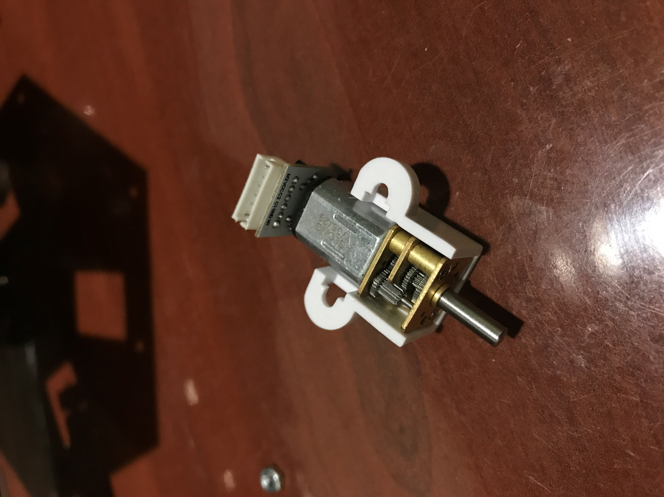Encoder

Bracket

Motor(with attached encoder)

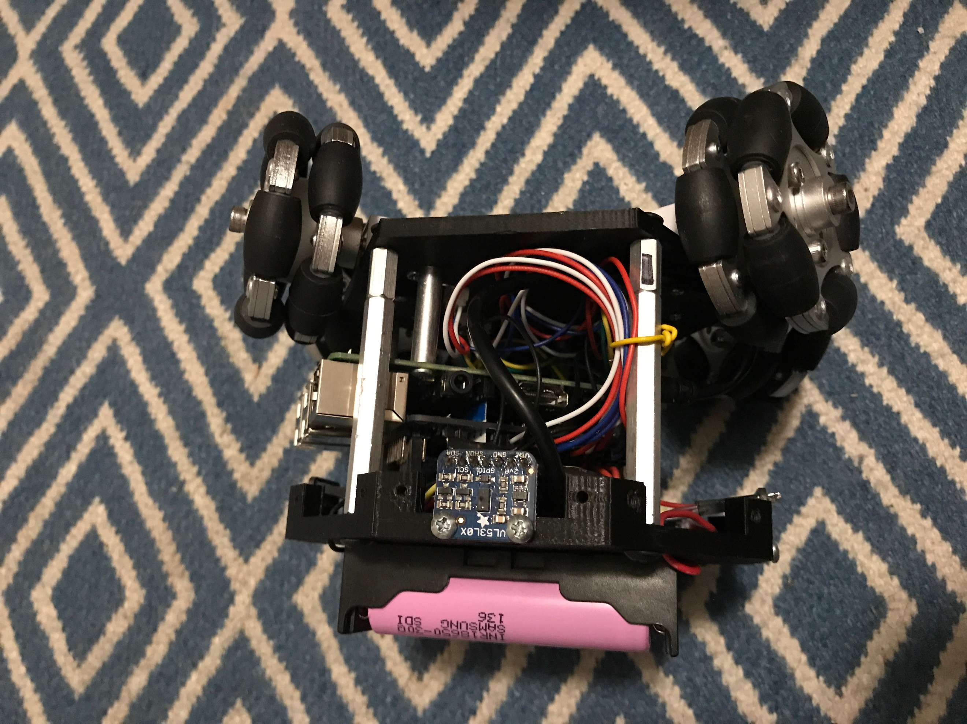* Build the wheels by putting the included hubs on one side of each wheel, as well as the wheel attachment hub, and center bolt. Then attach wheels to the motor shaft by sliding the shaft inside the hub, and tightening the hex key screws in the hub.

Bolt

Wheel

Hub

Attachment Hub

* Attach motors/brackets to chassis (Ensure the motor is oriented so that the wires from the encoder are passing upwards through the holes in the chassis)

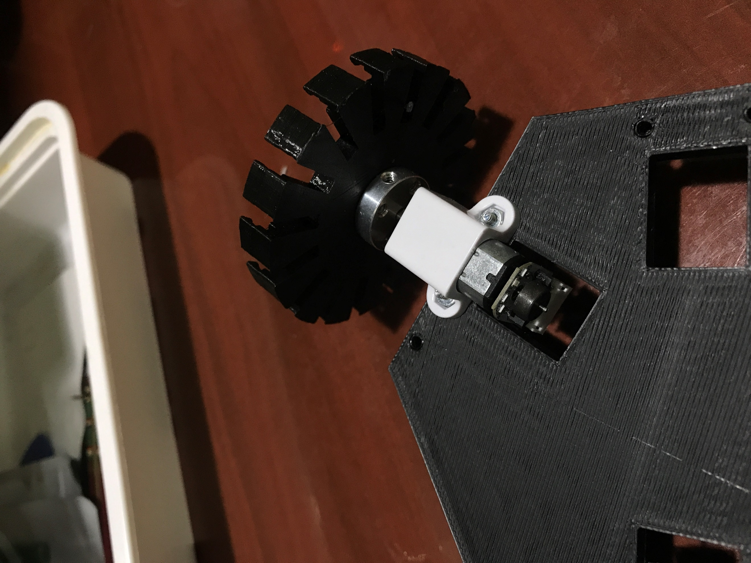 (Wrong wheel shown)

Hub

Screw and Nut(provided with brackets)

Motor(with attached encoder. Note: The wire connection is going through the hole in the chassis)

Motor Bracket

Encoder

*Note: This design can be improved upon by creating a means of adjusting the motor holders to ensure all four wheels have identical contact to the ground.

*Solder provided 40pin header9 to attach to the Pi), and 90 degree headers on the additional connections pins, motors, power, 5V row, 3V row, and ground row pins.

* Attach the encoder connectors to the encoders and screw in the spacers to the chassis.

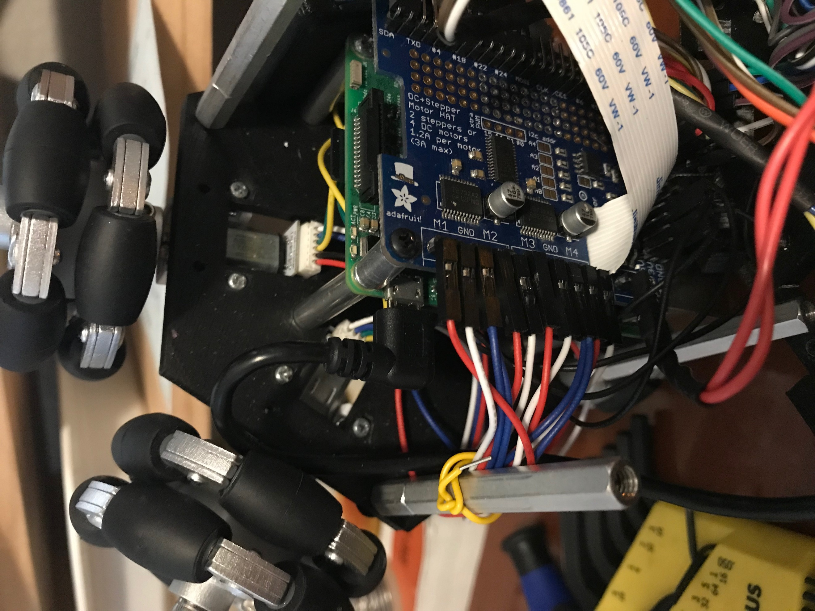Sensorholder spacers

Pi Spacers

Motorhat Spacer

*Pass the Camera cable through the Motorhat and connect it to the Raspberry Pi. Make sure the ribbon is oriented correctly

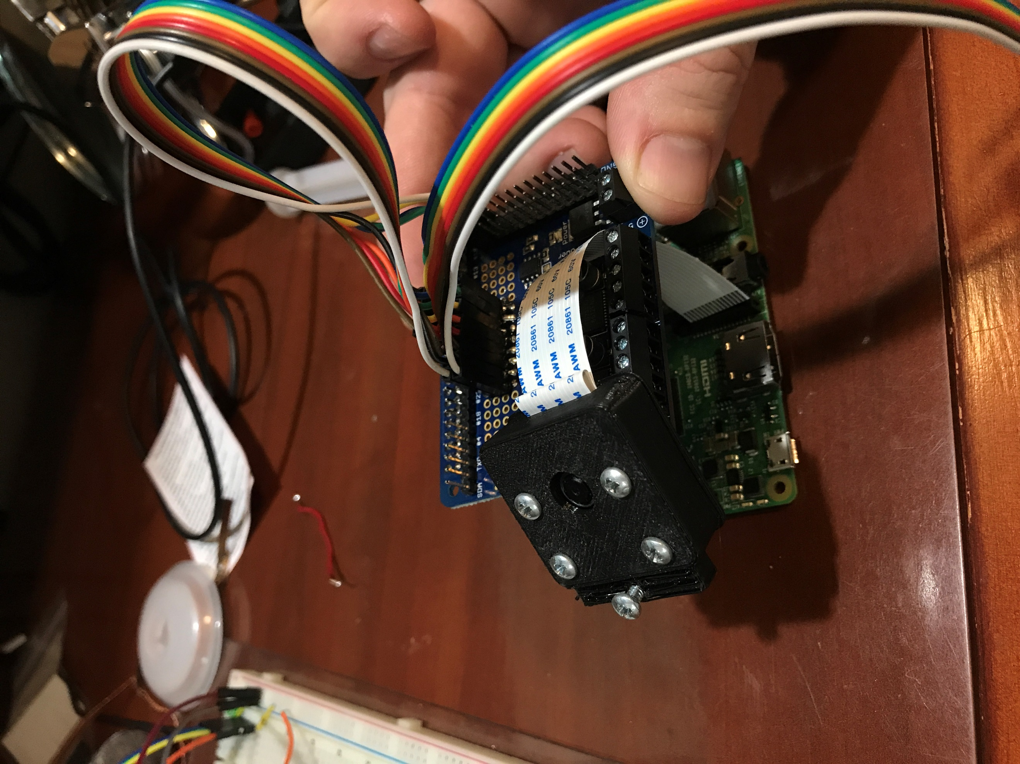

Ribbon Connectors

Camera Case Back

Camera Case Front

Camera case Screws

Mounting screw

*Attach Pi to spacers with screws

*Put camera in camera case, and screw in Camera case screws, as well as mounting screw

*Attach motor spacers to pi and Motorhat with screws

*Attach a dual female Dupont connector to each pair of green and yellow wires from each encoder/motor. Connect to appropriate 90 degree header pins on Motorhat.

*Attach single female Dupont connectors to remaining wires from encoders/motors

*Connect all encoder/motor wires to appropriate connections. (Refer to V3>Schematics)

*Solder male end of male/female pin connectors to VIN, GND, and SHDN pins on all four VL53L0X.

*Take one end off a male end of four male/male, and one male/female connector wires, and solder them together and cover the exposed wire with shrink wrap.(Try to match colors of wires if possible)

*Solder one male end into the SDA pad on each VL53L0X. the female end will be connected to the SDA pin on the Motorhat (which goes to the pi).

*Repeat the last two steps, but instead of soldering to the SDA pins, solder to the SCL pins on the VL53L0X, and the remaining female connector will be connected to SCL on the Motorhat.(which goes to the pi).

8**Connect remaining sensor wires to appropriate pins.

*Solder positive, negative and common wires to SPST switch, and run wires through sensor holder.

*Attach SPST switch to Sensor holder with glue(this can be improved upon with a switch that has attachment points)

*Solder a positive, and negative wire of around 6 inches in length to the appropriate terminals, and run wires through sensor holder

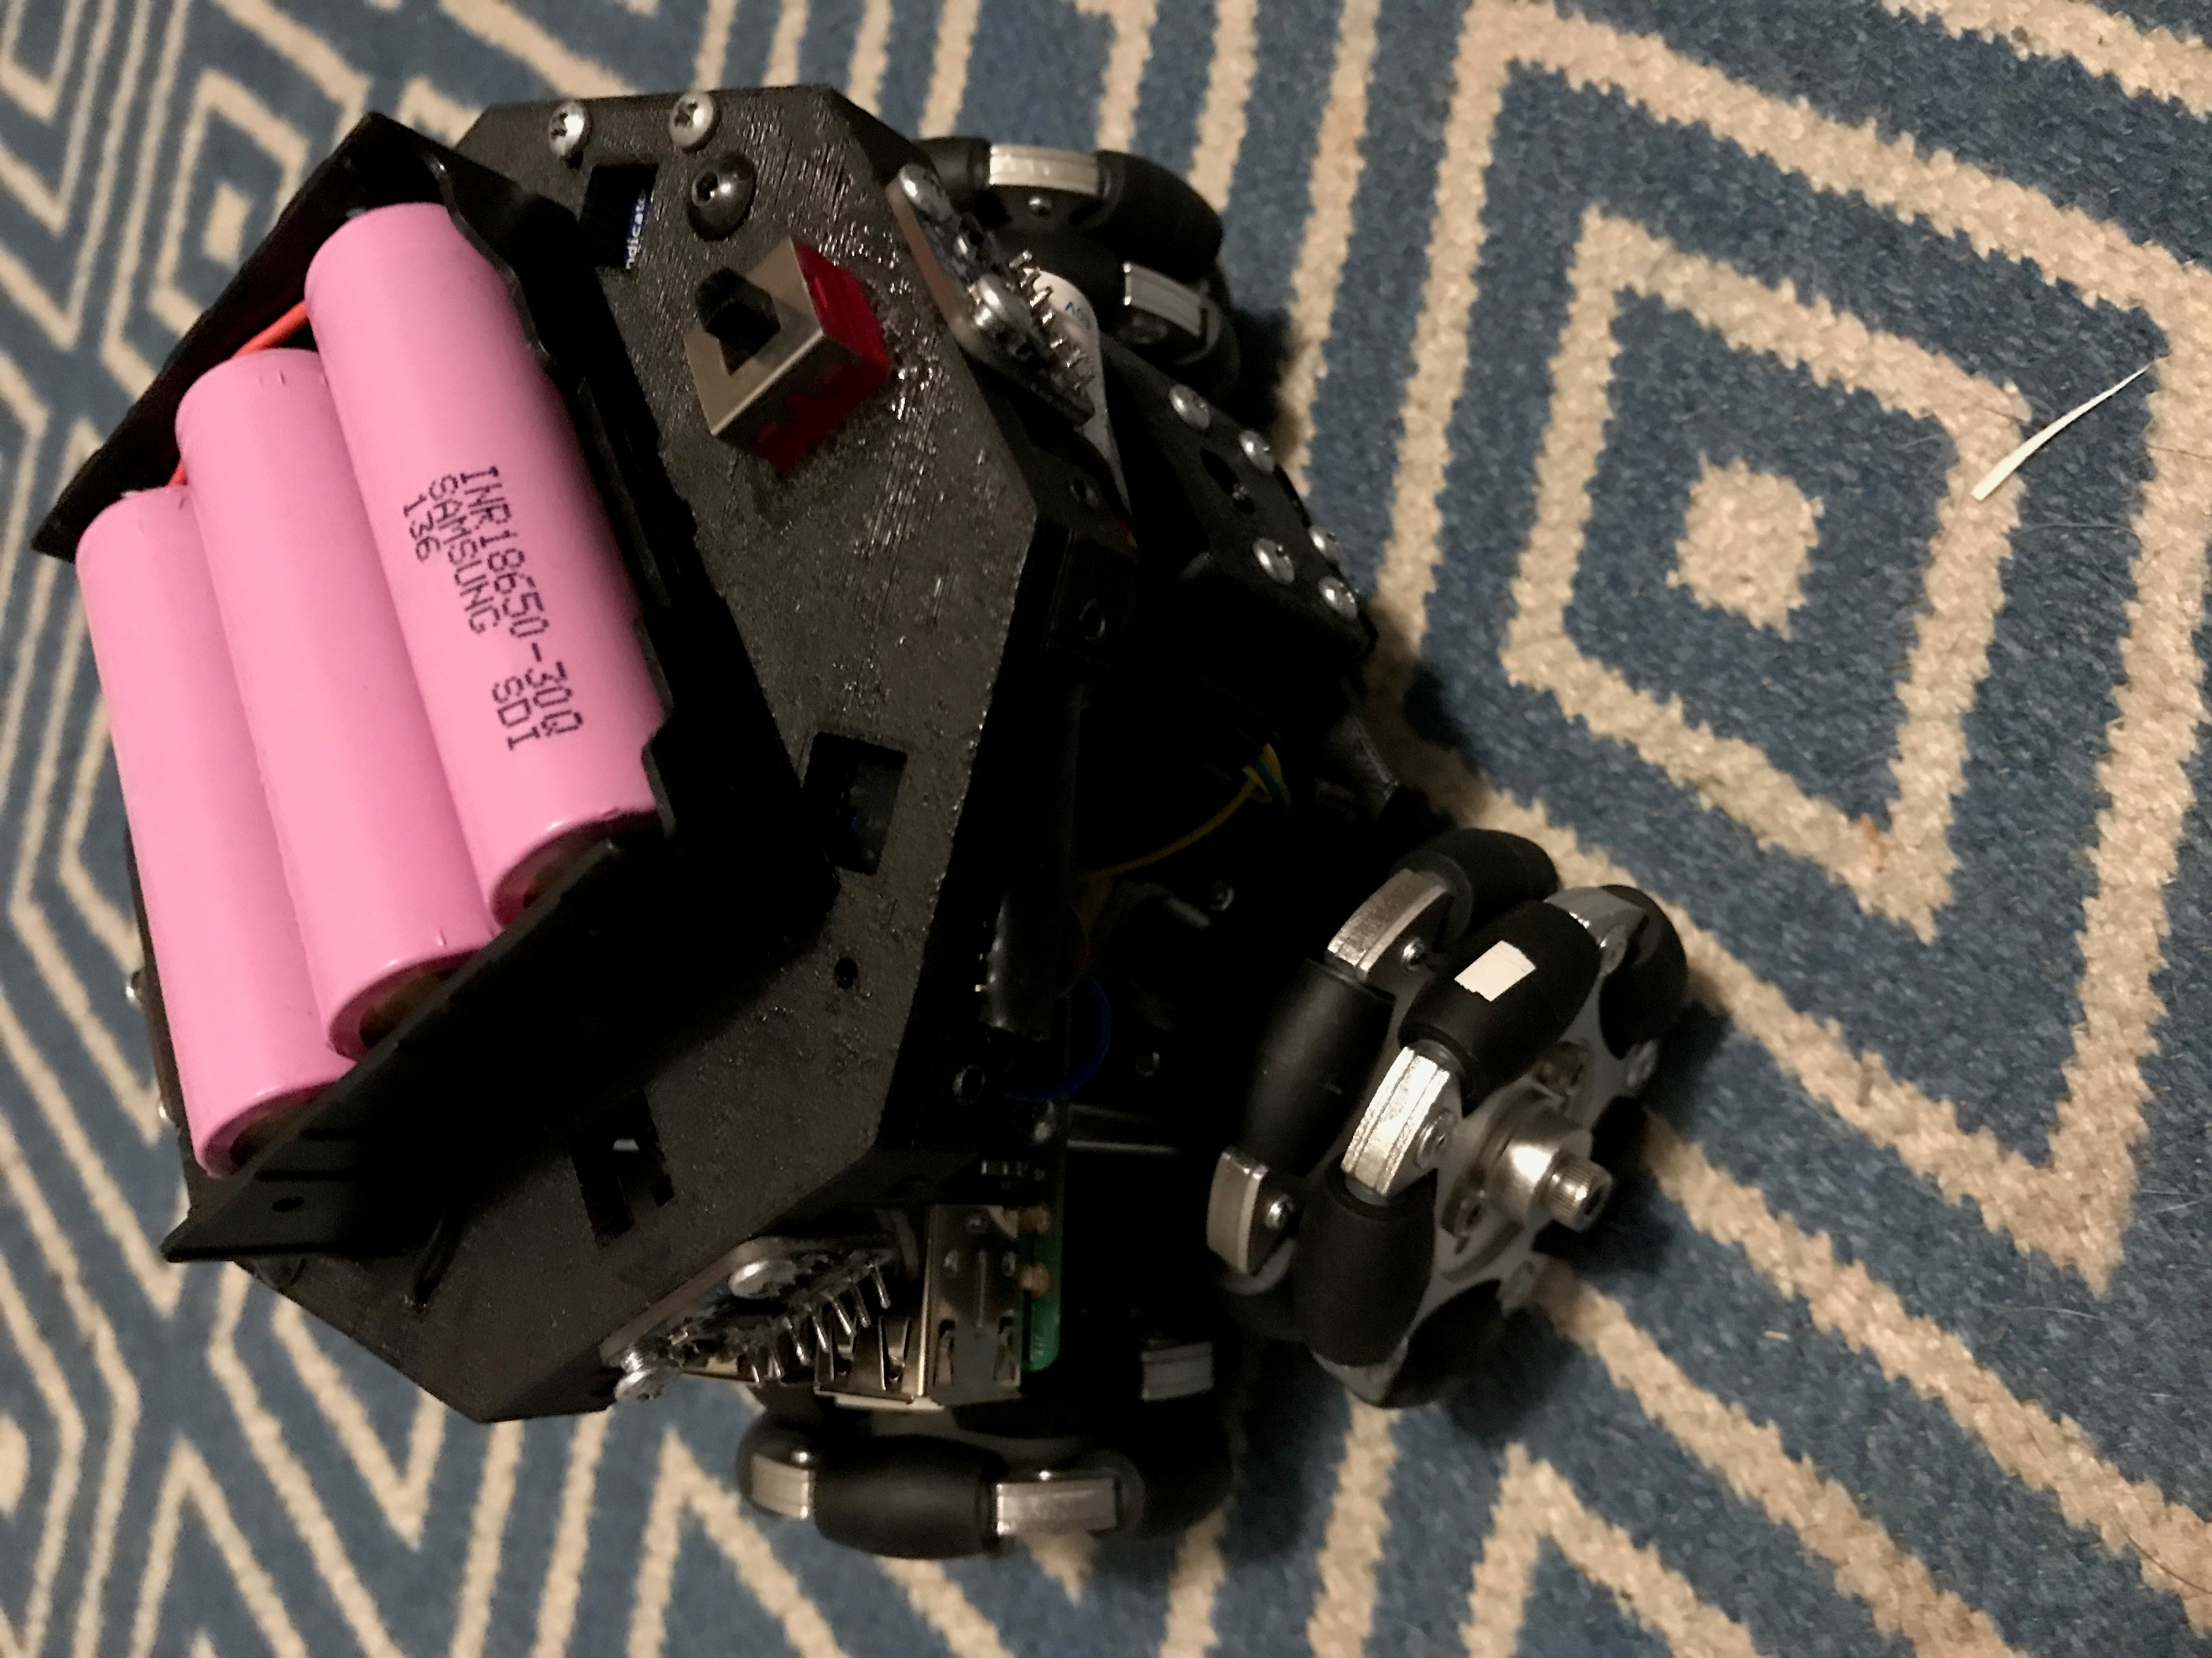*Attach the battery holder to the sensor holder with flathead screws, screwing downward in to the sensor holder.

**IMPORTANT** Place a protective layer of cardboard, plastic, or glue on top of screws before you put in the batteries to ensure they do not get punctured.

Battery holder

SPST Switch

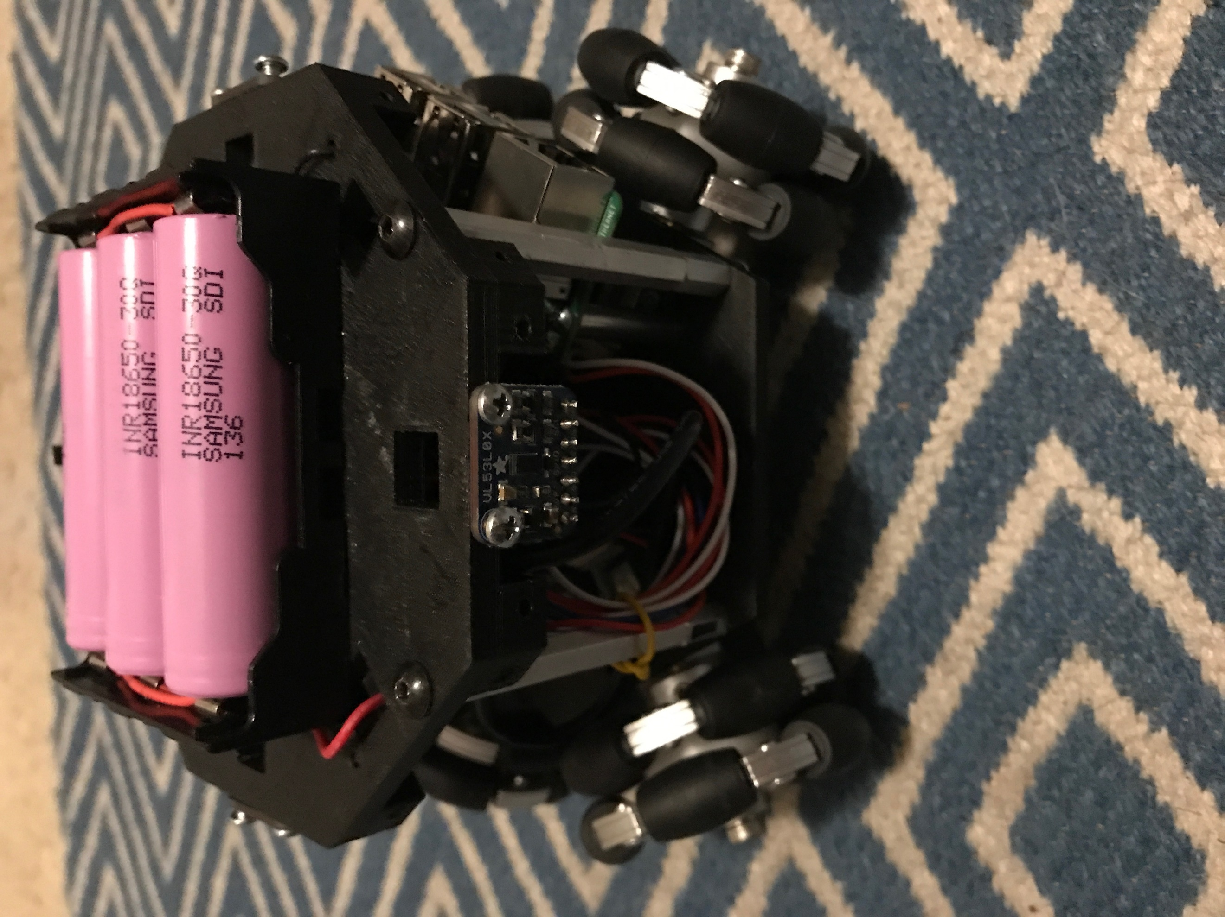

Positive Wire

Negative Wire

*Solder battery wires to Powerboost 1000. (refer to V3>Schematics)

*Attach USB cable to Powerboost for Raspberry Pi. (refer to V3>Schematics)

Wiring for the Powerboost 1000 and VL5L0X can be found with the robot builds for the Introduction to Mobile Robotics class. There are also schematics in .jpg, and Fritzing formats in V3>Schematics folder.

*Make sure each of the four VL53L0x sensors are in their approximate position and attach sensor holder to the sensor holder spacers with screws.

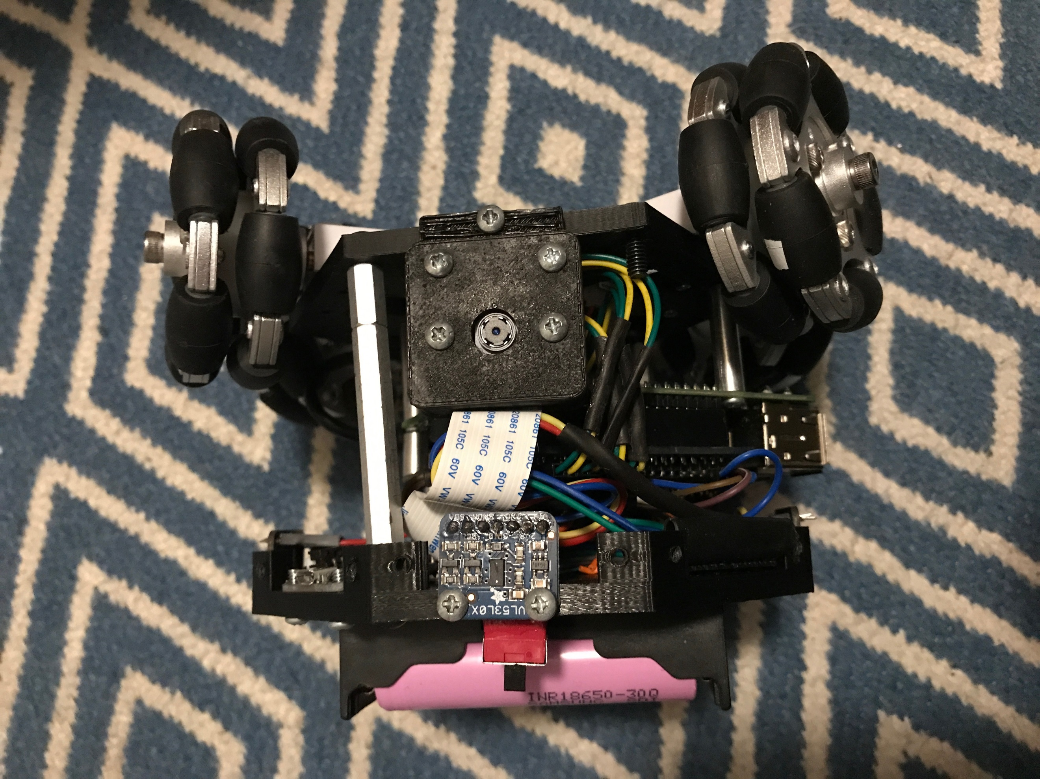Sensor Holder

Sensor holder spacer

*Be sure to make sure there is enough clearance when attaching the VL53L0X to the sensor holder as it there are some small components that are very close to the holes that can be damaged if the screws are tightened completely and hit against them.

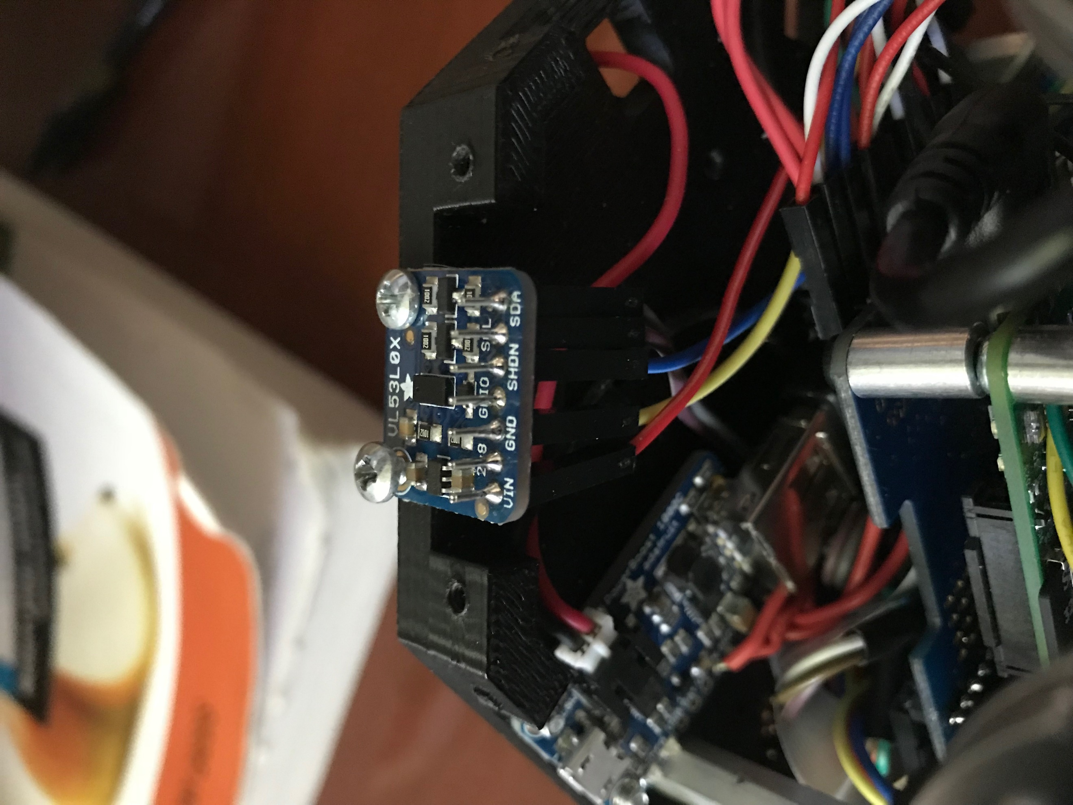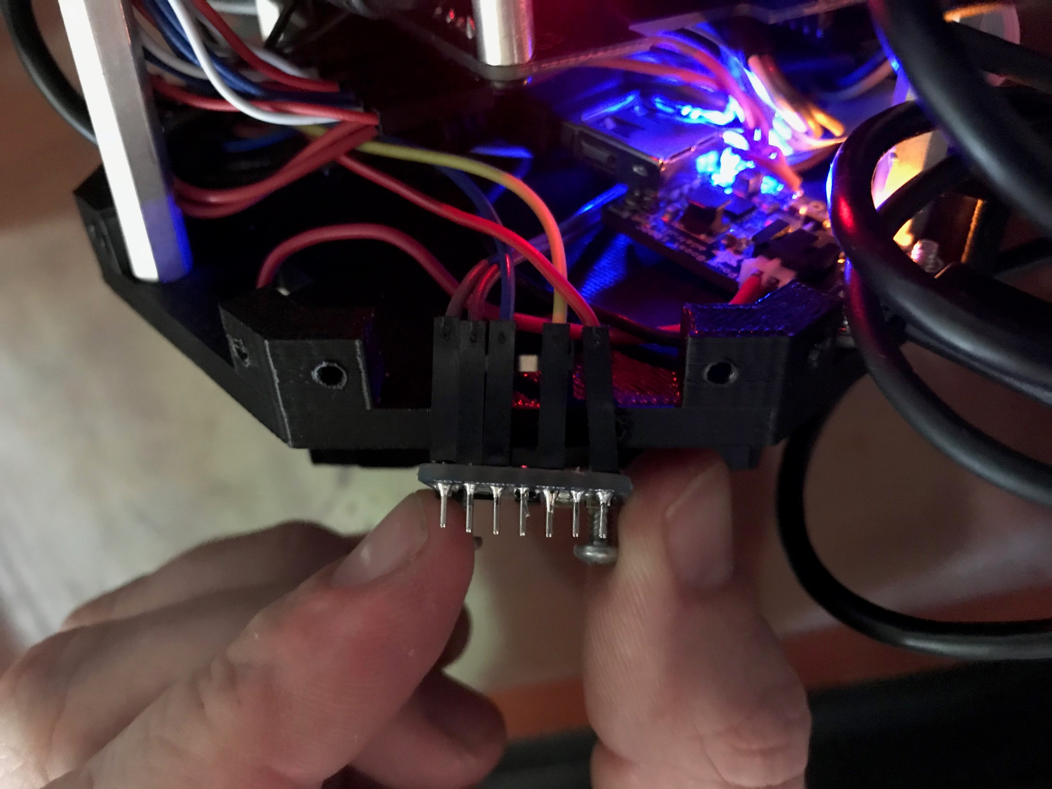

VL5L0X

# Rejoice. You are finished.

